- TITLE OF THE PROJECT
Investigator One,¹ Investigator Two,² Investigator Three^{3,*}
¹Designation, Department, Organization, Address, Telephone, e-mail
²Designation, Department, Organization, Address, Telephone, e-mail
³Designation, Department, Organization, Address, Telephone, e-mail
*Corresponding investigator

This document can be used as an instruction set as well as a template for submitting a project proposal for Nanotech Hackathon at the Centre for NEMS and Nanophotonics (CNNP), IIT Madras under the INUP-i2i program. The length of this proposal document should not exceed 3-4 pages.

2. AREA & DURATION:

Please mention research area of the project (Energy and Environment/Healthcare) and expected duration of the project in months (Maximum 6 months).

3. ABSTRACT:

Abstract: The abstract should be concise with a maximum of 150 words. The technical abstract should be a condensed version of the project. State concisely the significance of the project, what is expected to be accomplished and how, and the period of performance of the project.
Index Terms: Enter few keywords relevant to the project

4. INTRODUCTION:
Give a brief introduction of the project. The first paragraph here can include motivation and the literature review describing the relevance of the proposal. A research work can be cited like this with corresponding entry in the references [1…] at the end.
The second paragraph can define the problem statement and explain what is going to be done by you in the project and its impact.
5. APPLICATION:
End application of the proposed device and elaborate on how the proposed device would address the societal needs

5. TECHNICAL DETAILS:
Populate the below sub-sections with proper figures and descriptions.

A. Research Methodology

Clearly state the methodology proposed for executing the research plan.
(In case, some part of the project work is to be done at parent institution, please mention the work to be carried out at parent institute and work to be carried out at CNNP, IIT Madras separately)

B. Process flow

Give a detailed step-wise process flow if possible depict it pictorially as shown below:

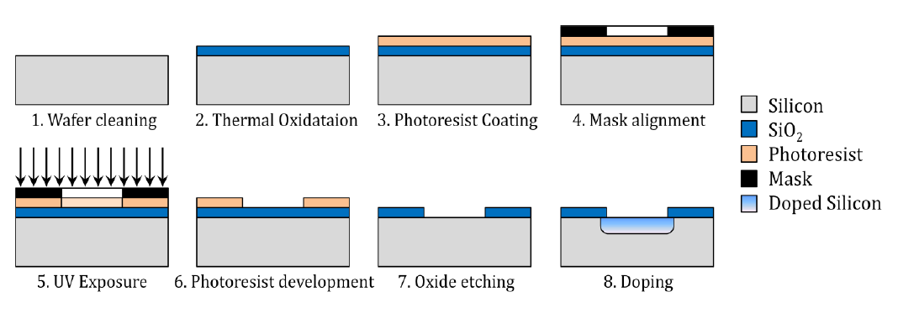

C. Device/Mask structure with picture/schematic (if any):

Give a description of the device/mask structure preferably as a picture properly annotated with critical dimensions. A sample device schematic has been shown below:
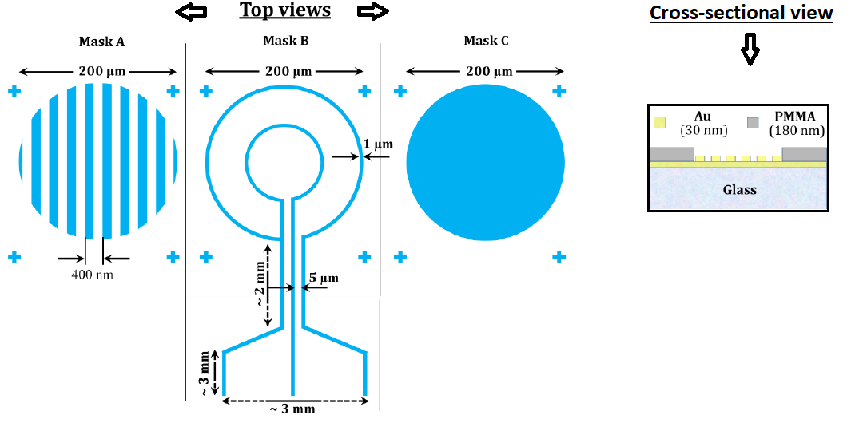

D. Equipment required:
List of fabrication and characterization equipment required for the project
(Please refer to: https://mems.iitm.ac.in/cnnp/capabilities/)
Equipment required from CNNP, IIT Madras (Add more if required)

1
2
3

6. WORK PLAN:

Time schedule of activities to be carried out at CNNP, IITM.
7. CONSUMABLES:
List of consumables (wafers, gases, liquid chemicals, metal targets etc.) required for the project.

Consumables
1
2
3
.
.

- BRIEF HISTORY OF THE SAMPLE:
Please give a brief history of materials and processes.
9. REFERENCES:
[1] Wong, Paul TP, and C. Psych. "How to write a research proposal." Langley: Trinity Western University Langley. Retrieved 26 (2016).

